INTRODUCTION
Routine and preventive maintenance are lo be performed on your normal periodic service call. This section discusses how to change discs and titles, how to collect money, audit statistics, and preventive maintenance procedures.

LIFTING THE TITLE RACK

A
CAUTION:
Do not attempt to turn the CD title pages by hand. Use the handwheel on the back of the title rock isee Uguie 1-2).

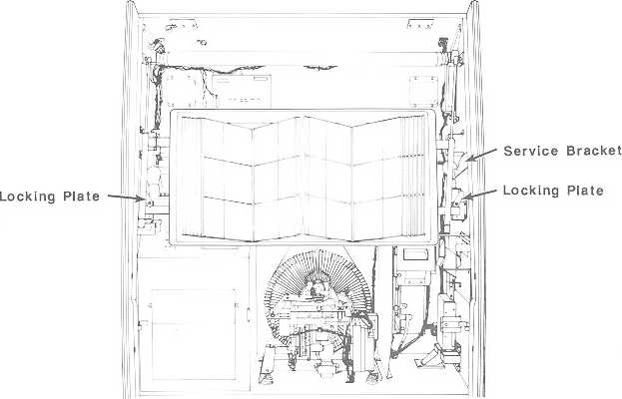
2/822611
Figure 3-1. Lifting The Title Rack

CD- J00 Phonograph

Before you begin changing discs, you may wish to lift the title rack to give yourself more room to work. Lift the title rack as follows:
- Open the phonograph top door.
- Rotate the two locking plates [seejiyure 3-1) away from the title rack bar and lift the bottom of the title rack up and toward you with your left hand,
- With your right hand, swing the title rack service bracket out to hold the title rack up.

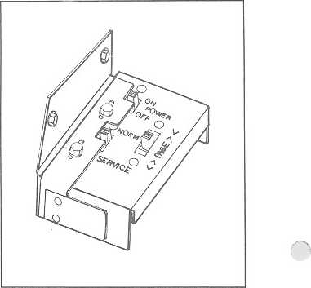
Figure 3-2. Service Switch

DOING AN AUDIT
The following pages describe how lo:
- Access the phonograph's audit menus and extract audit figures
- Change title strips and discs
- Collect money
You can perform these three activities in any order that you wish.

COLLECTING AUDIT FIGURES
the pages that follow describe the major auditing activities that need to be done on a routine service call. If you wish to do additional auditing, you can obtain the additional commands from table 3-1, the AUDIT commands.

Entering The Service Mode
1. Open the top door and place the SERVICE switch [figure 3-2) in the SERVICE position. The phonograph display will say ' SERVICE MODE *. AT this point, the phonograph is in Security Level 1. You can only view audit information in this security level. In order to clear (he cash, play, and popularity figures you must obtain and properly enter the security code for SECURITY LEVEL 2.

Entering A Security Level
- Make sure that you have placed the SERVICE switch in the SERVICE mode and that ' SERVICE MODE '"is on the keyboard display.
- Press 0 to select the Security submenu then type 0 to select CODE ENTRY. Type the security code, and then press POPULAR. The phonograph will automatically go to the security level that matches the code that you typed in. if the security code is set to the factory code [OOOO], or If the Level 2 and Level 3 codes are the same, you will see that the display says that you are on Level 3. If you are on Level 3 Security, be careful . . . any changes that you request will be made.
- Press and hold RESET while you press POPULAR two times. This will take you back lo the • SERVICE MODE * display, which is called the "MAIN menu".

3-2
2IB226If


Section 3: Routine Servie «

NOTE:
If you find thai you are not seeing the display that you expect, you con always: press and hold RESET and then press POPULAR three times. This will take you back to the main menu.

At this point you can begin doing the audits. Refer La Lhe CD-100 Servtce Mode Map (figure 2 7) for a diagram of the audit menus and commands. Do audits for cash, play, non-resettables, clear disc popularity, clear cash, clear plays in Lhe following manner:

Cash Audits
- Type 100, This displays the CURRENT CASH value. Record the CURRENT CASH figure in your usual way and go 1o the nest step.
- Press and hold RESET and then press L. This will move you down to the nest display. Record the CASH VALUE in Lhe usual way.
- Repeat Step 2 until you do the last CASH audit, which is Lhe #2 BILLS audit. Do this audit and Lhen press and bold RESET while you press POPULAR three limes.

Play Audits
- Type 110. This displays the FREE CREDITS value. Record the FREE CREDITS figure in your usual way and gu tu Lhe next step.
- Press and hold RESET and then press 1. This will move you down to the next display. Record the credit value in the usual way.
- Repeat Step 2 until you do the last PLAY audit, which 3s the MOST POPULAR PLAYS audit. Do this audit and then press and hold RESET while you press POPULAR three times.

Non-Resettable Audits
L.Type 120. This displays [he NON-RESETTABLE CASH value. Record the NON-RESETTABLE CASH value in your usual way and go to the next step,
- Press and hold RESET and then press L. This will rnuve you down to the next display. Record the value in the usual way.
- Repeat Step 2 until you do the last NQN-RESETTABLE audit, which is the ALBUMS FLAYED audit. Do this audit and then press and hold RESET while yuu press POPULAR three times. This returns you to the main menu.

Most Popular Disc
1. Type 17, The most popular disc number will be displayed.

21622611
CD- ÏOO Phonoa/apt}

2. If you wish to know the next-to-the-most popular, press and hold RESET and then press 3.
Press and hold RESET and then press 3 to display each successive "Most Popular" disc. Press
and hold RESET and then press 2 to move through the popularity display toward the most
popular disc.
3, Press and hold RESET while you press POPULAR twice. This returns you to the main menu.

Least Popular Disc
- Type IS. The least popular disc will be displayed.
- To display the next "Least Popular" disc, press and hold RESET and then press 2. Press and hold RESET and then press 2 to display each successive least popular disc. Press and hold RESET and then press 3 to move through the popularity display toward the least popular disc.

3. Press and hold RESET while you press POPULAR twice. This returns you to the main menu.

Most Popular Selection
1. Type 19. The most popular selection number will be displayed.
2. To display the next most popular selection, press and hold RESET and then press 3. Press and
hold RESET and then press 3 to display each successive most popular selection. Press and
hold RESET and then press 2 to move through the popularity display toward the most popular
selection.
You can request the popularity for a particular selection by pressing the selection number (four digits).

Clearing The Audit Values
The three CLEAR options will not clear the corresponding audit value until the POPULAR button is pressed.

For example:
Yon can display the CLEAR CASH message and then move to CLEAR PLAYS and then move back to CLEAR CASH without actually clearing either set of values.

The following steps describe how to perform each of the three CLEAR commands as a separate activity. If you wish to use the "short cut" method. Jollow tlv? Using Tlie CD-ÏOO Commands instructions in Section 2. Each of these commands may be executed from SECURITY LEVEL 2 or 3.

CLEAR CASH
1. Make sure that you arc in the SERVICE mode and that " SERVICE MODE * is on the display.
1. Type 14. The message CLEAR CASH will appear on the display. Press POPULAR to clear the cash values. The display will blink when the command is executed.
3, Press and hold RESET while you press POPULAR twice.

21322611
Section 3; Routtn* Sínico

CLEAR PLAYS
- Make sure thai you are in the SERVICE mode and that ' SERVICE MODE - is on the display.
- Type 15. The message CLEAR PLAYS will appear on the display. Press POPULAR to clear the play values. The display will blink when the command is executed.
- Press and hold RESET while you press POPULAR twice.

CLEAR SELECTION POPULARITY
- Make sure that you are In the SERVICE mode and that * SERVICE MODE " Ls on the display.
- Type 16. The message CLEAR SEL POP will appear on the display. Press POPULAR to clear the popiilariiy values. The display will blink when the command is executed.
- Press and hold RESET while you press POPULAR twice.

CHANGING CD'S AND TITLES

A
CAUTION:
Do no! attempt to lutn the CD title pages by hand. Use the hondwheel on the back ot the title rack isee figuie 1-2).

The procedure for loading CD's and titles into an empty phonograph is different from the procedure to change CD's and titles. Please make sure that you are following the procedure that describes your situation.

Preparing Titles For The Title Rack
- If your titles have not been shipped with the discs or pre-prlnted, you will need to prepare the title strips yourself.
- Tear each title strip from the title sheet so that the two perforated columns appear on the side of the title strip (the shaded portion of the title strip in figure 3-3 represents a title strip that has been removed from the title sheet].
- Fold the title strip along the inner most perforated line on both sides of the title strip (see Mure 3-4),
- Locate the CD album booklet that matches the title strip that you have Just made, if the CD booklet is more than two sheets thick, remove the Inner sheets so that the booklet is no thicker than two title strips.
- Insert the CD booklet under the top and bottom tabs of the title rack. Slide the CD booklet toward the pivot of the title rack until the booklet Is trapped by the molded stops on the title page (see figure 3-5, ref A).

2IË226H

CD'tOO Phonograph

Sepárale Hera

HI .
Tn.r.híi i ——i Ht.i d
▼ L. I

Sepárale here

-Fill KIJ
-H.tb: Hi-

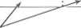
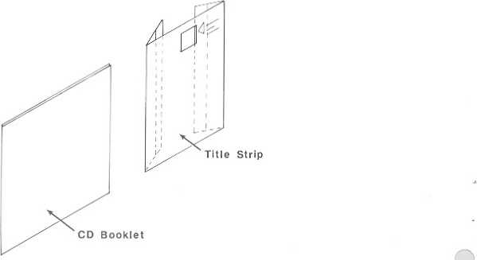
BLANK TITLE SI HIP
CD-100
Figure 3-3. Blank Title Sheet
Discard
Seguráis H₍ip
Figure 3-4, Folding The Title Strip
2:;2Z->\)

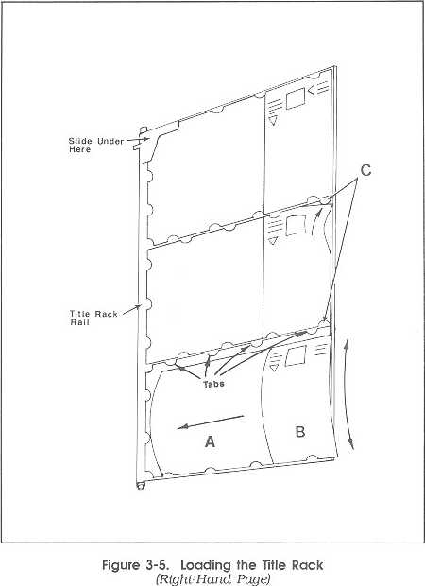
Section 3; iourr™ SbhjIcb

6, Insert the folded title strip under the top and bottom tabs of the title rack_{r} SJide the title strip until the disc number shows in the opening or the title strip and the title strip is locked in place by the molded stops (see figure 3-5, ref B).

7. All of the labs surrounding the CD booklet and title strip should be holding them in place. If you missed a tab, carefully tuck the loose paper under the tab as shown In figure 3-5, ref C.

8. Repeat steps 4 through 7 until all titles are installed. Use the CHANGE PAGE buttons to change title rack pages. Insert filler title strips (Part Number 30940601) to fill out any unused space left on a page. Insert these in the same way that you installed the fill-in title strips.

21S226I 1
CD-100 Phonograph

Changing Title Page Limits On An Installed Phonograph
- Unlock and open the tup door, if you have not already.
- Move the SERVICE switch to the SERVICE position, if not already done [refer to figure 3-2).
- Make sure that ' SERVICE MODE " appears on the display.
A. Type 00 and then type the security code to gain access to SECURITY LEVEL 3.
6. Press and hold RESET and then press POPULAR twice. This will return you to the main menu [the same display as step 3}.
G. Type 24 and you will see the display for entering the first page number to use and the last number to use. Type the first page number (page numbers are counted from the left to the right] and press POPULAR. Notice that the blinking number has moved to the right. Type the last page number to be used and press POPULAR.
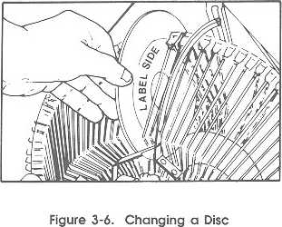
Changing Discs
You can |1J initialize each disc as you change it, or [2] you can ■write down all of the disc numbers and then type them all into the INITIALIZE command. The following steps describes the second method.
Change discs as follows:
- Unlock and open the top door, if not already done.
- Move the SERVICE switch to the SERVICE position, if not alreadv done {refer to figure 3-2].
- Press the SCAN button to move the disc space to the left or right of the transfer arm.
- Slide the old CD out or the slot and slide the new CD into the slot [see figure 3 6} with the label to (he right. Write the disc number on a note pad.
- Repeat step A until all discs have been changed,
- Make sure that you have placed the SERVICE switch in the SERVICE mode and that ' SERVICE MODE ' Is on the keyboard display.
- Type 31. Enter the CD numbers that you have changed and press POPULAR. After you have entered all of the disc numbers, place the phonograph Into the NORMAL mode and the initialization process wit I start. Selections can be made while the new discs are being Initialized.

NOTE:

When changing discs, be sure to keep the magazine disc load approximately balanced. It the magazine Is partially loaded with all discs on one side, The sprag wheel may lock and the magazine will not turn.

3-3 2)82261!

COMPLETE AUDIT COMMAND LIST
Table 3-1 is a complete list of the Audit commands with an explanation of what each command does.

Table 3-1. Audit Commands
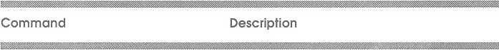

1 AUDETS - Are the functions and menus that allow you to display and reset the various accumulated figures for money, popularity, number of plays, and credits.
- Cash Audiis - Is the menu that allows you to display, but not change, cash totals, number of coins through the coin switches, and the total number of bills,
- Play Audits - Is the menu thai allows you to display, but not change, credits, autoplays, mechanism plays, and album plays,
- Non-Resettables - Is the menu that allows you to display the ongoing totals. These totals cannot be reset from any security level.
- Clear Disc Popularity - Clears the popularity for all discs. This option should only be used after the popularity figures (Selections 7, 3, and 9 in this menu) have been read and recorded. Press POPULAR to clear the popularity values. The display will blink when the command is executed.

COMMANDS 14, 15, AND 16 CAN BE EXECUTED FROM LEVEL 2

14 Clear Cash - Clears all current cash totals. This option should only be used after the figures for Cash Audits {selection 0 in this menu) have been read and recorded. Press POPULAR to dear the cash audit values. The display will blink when the command is executed.

15 Clear Plays - Clears all current play totals. This option should only be used after the PLAY AUDIT figures in PLAY AUDITS (selection 1 in this menu) have been and recorded. Press POPULAR to clear the play audit values. The display will blink when the command is executed

16 Clear Selection Popularity - Clears all current selection popularity. This option should only be used after the PLAY AUDIT figures in PLAY AUDITS (selection 3 in this menu) have been and recorded. Press POPULAR to clear the selection popularity values. The display will blink when the command Ls executed.

17 Display The Most Popular Disc - Displays the most popular disc number (00-99), followed by the number of plays (9999 maximum) that disc bad. To display the next most popular disc, press and hold RESET and then press 3. Press and hold RESET and then press 3 to display each successive most popular disc. Press and hold RESET and then press 2 to move up through the popularity display toward the most popular disc.
You can request the popularity for a particular disc by pressing the disc number,
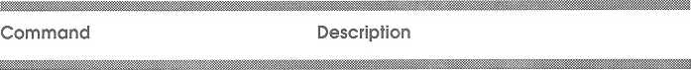
Table 3-1. Audi! Commands
Continued
- Display The Least Popular Disc - Displays the least popular disc number (00-99} followed by the number oí plays thai the disc had. Tu display the next "least popular' disc, press and hold RESET and then press 2. Press and hold RESET and then press 2 to display each successive leasLRESET and then press 3 lo move up
through the popularity display toward the leasl popular disc.
You can request the popularity for a particular disc by pressing the disc number.
- Display The Most Popular Selection - Displays the most popular selection number [disc 00-99 followed by selection 00-99. a total of four di£itsf. followed by the number of plays (9999 maximum] that selection had. To display the next "most popular" selection, press and hold RESET and then press 3. Press and hold RESET and then press 3 to display each successive most popular selection. Press and hold RESET and then press 2 to move up through the popularity display toward the most popular selection.
You can request the popularity for a particular selection by pressing the selection number (four digits).

10 CASH AUDITS - Allows you to display, but not change, cash totals, number of coins through the coin switches, and the total number of bills.
- Current Cash - Displays the total cash amount collected since the last time the CLEAR CASH command (Selection 4 in the AUDITS menu] was used.
- Current Bill - Displays the total amount of bills collected since the last time the CLEAR CASH command (Selection 4 In the AUDITS menu) was used.
- Current Coin' - Displays the total amount of coins collected since the last time the CLEAR CASH command (Selection 4 in the AUDITS menu) was used,
- Current WoElbox' - Displays the total amount of money collected by wallboxes since the last time the CLEAR CASH command (Selection 4 in the AUDITS menu) was used.
- Current Number Of Type 1 Coins - Displays the total number of Type l coins collected since the last time the CLEAR CASH command (Selection 4 in the AUDITS menu) was
used.
- Current Number Of Type 2 Coins - Displays the total number of Type 2 coins collected since the last time the CLEAR CASH command (Selection 4 in the AUDITS menu) was used.
- Current Number Of Type 3 Coins - Displays the total number of Type 3 coins collected since the last time the CLEAR CASH command (Selection 4 in the AUDITS menu) was used.
Table 3-1, Audit Commands
Continued

107 Current Number Of Type 4 Coins - Displays the total number of Type 4 coins collected since the last time the CLEAR CASH command (Selection 4 in the AUDITS menu) was used.
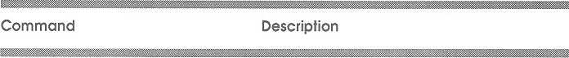
106 Number Ot Type 1 Bills - Displays the total number of Type 1 (£1} bills collected since the last time the CLEAR CASH command (Selection 4 in the AUDITS menul was used.
109 Number Of Type 2 Bills - Displays the total number of Type 2 ($5) bills collected since the last time the CLEAR CASH command (Selection 4 in the AUDITS menu) was used.

11 PLAY AUDITS - Allows you to display, but not change, credits, autoplays, mechanism plays, and album plays.
- Free Credits - Displays the number of free credits given since the last lime the CLEAR PLAY command (Selection 4 in the AUDITS menu] was used.
- Paid Credits - Displays the number of paid credits given sfnee the last time the CLEAR PLAY command (Selection 4 in the AUDITS menu) was used.
- Autoplays - Displays the number of Auloplays made since the last time the CLEAR PLAYS command (Selection 5 in the AUDITS menul was used.
- Mechanism Plays - Displays the number of times the mechanism has dispensed CD's since the last time the CLEAR PLAY command [Selection 5 In the AUDITS menu) was used.
- Album Buys - Displays the number of limes albums have been bought since Ihe last time the CLEAR PLAY command [Selection 5 in the AUDITS menu] was used.
1 IS Most Popular plays - Displays the number of limes that the POPULAR button was used tc play the most popular selection.
116 Normal Selections - Displays the number of selections made from the keyboard.

12 NON-RESETTABLES - These totals for cash, plays, and credits can be displayed from any security level, but they cannot be reset from any security level. These totals constitute the permanent phonograph history.
¹ This information is displayed as the number of units in Version 1.0 and 1.1
1money=unlts x multiplier and the dLsplay says: CASH ~ K In Version 1.2 and
subsequent, this value is displayed as the actual cash value (the display says:
-CASH = ).
- Cash¹ - Displays total cash [displayed as the number of nickels) received by the phonograph
- Bill¹ - Displays total bill cash received (displayed as the number of nickels) by the bill acceptor

21622611
3-PI

Table 3-1. Audit Commands
Continued

Command
Description

- Coin¹ - Displays total coin cash received (displayed as the number of nickels) by (he coin acceptor
- Wallbox¹ - Displays total cash received [displayed as the number of nickels] by all mailboxes
- Free - Displays total free Credits
- Paid - Displays total paid for credits
- Most Popular - Displays the total number of Most Popular selections
- Mechanism - Displays the tola! number of mechanism cycles
- Album - Display total number of limes an entire album was selected,
139 Selections - Displays the total number of selections made using the keyboard.

1 This information Is displayed as the number of unils in Version 1,0 and 1.1 ïmoney=units x multiplier and the display says: CASH ■ -- -- -- »-), in Version 1.2 and
subsequent. Oils value Is displayed as the actual cash value tlhc display says:
-CASH =
>-

J-12
2192161}

Section J: Reu'lrw Swvfoa

Col leering Money
- Open the top door (if it is not already open) and reach in, behind the bill acceptor, and unlock the bill acceptor bill box,
- Remove the currency and close and lock the bill box.
- Close the top door.

PREVENTIVE MAINTENANCE
Preventive maintenance should be performed at the regular intervals specified, while adjustments should be made only when necessary.
In addition to cleaning the cabinet each time the location is visited, clean the interior every three to six months, as required. Keeping the cabinet interior clean reduces dust, resulting in Increased disc and component life [see table 3-2 for details).
- Use a vacuum cleaner to remove heavy dust deposits.
- Use a clean, lint free cloth saturated En denatured alcohol to clean mechanical parts.
- Clean electrical parts using a clean, dry cloth or camel hair brush.

A
WARNING:
Use solvents in a well ventilated area only. Do not use solvents on plastic parts.

ACTION REQUIRED PROCEDURE
Table 3-2. Cabinet Cleaning
1- | Clear Glass | a. | Clean all glass with a paper towel and a non-abrasive glass cleaner such as Windex.
 |  | b. | Dry wirh a clean, lint-free cloth.
2. | Clean painted | a. | Clean all painted wood and metal surfaces with mild soap and water. DO NOT USE
 | wood and metal |  | SOLVENTS.
 | surfaces | b. | Apply a good quality auto or furniture wax lo protect the finish.
3. | Clean chrama trim | a. | Use a damp or dry cloth to remove any dust or dirt.
 |  | 3. | Use mild soap and water to remove stubborn deposits. Do nat use strong
 |  |  | detergents or abrasives of any kind.
4. | Clean plastic trim | a. | Wipe all plasSic surfaces with a damp or dry cloth only. DO NOT USE SOLVENTS.
 | Clean electrical | a. | Clean all electrical components with a clean, dry, lint-free cloth or a soft bristled
 | components |  | brush only.

COIN ACCEPTORS 3CQIN

FRONT VIEW
BACK V I EW

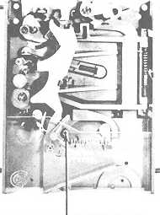
TO REJECT DIMES ADD COINCO No. 903-915 SLOCK OUT WIRE
;0IN ACCEPTORS 4 COIN
REMOVE COVER AND DRIVE No. 6-32 SCREW INTO BOSS A3 SHOWN TO REJECT NICKELS

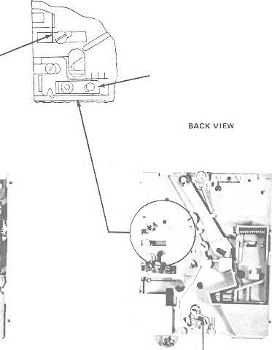
FRONT VIEW
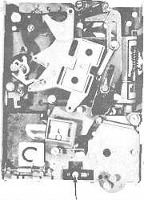
LINE UP EDGE OF DEFLECTOR WITH THIS LINE
TO IMPROVE S SLUG H EJECTION ADJUST AS SHOWN
LINE SEPAHATOR AS SHOWN
Figure 3-7. Coin Acceptors
MOVE THIS BRACKET TO RIGHT TQ REJECT NICKELS 10« JUST FAR ENOUGH TO LEFT TO ACCEPT NICKELSI

TO REJECT DIMES ADD COINCO No. 90391^ SLOCK OUT WIRE

S- ¡4
219226tt

Section St Hotline Service

COIN ACCEPTORS (optional) Coin Switch
Coin Switch Wiring Note:
Table 3-2 dhows how Lo set the coin switch values Tor 3-coin and 4-coin acceptors. Programing The multiplier (PRICING SELECTION 3] should always be set to 5 for U.S. currency.

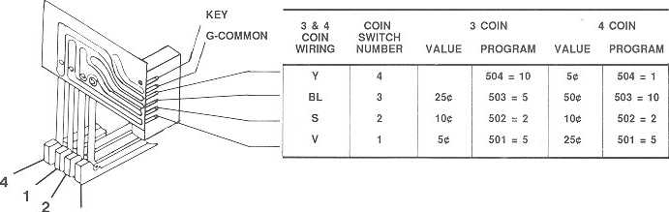
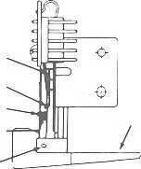
Table 3-3. Coin Switch Wiring
CHECKS AND ADJUSTMENTS Coin Lever
ST |f FWER ÜLADÉS fl TO 15 GFÍ4MS
WON-MOV ING SWITCH BLADE
MOVING SWITCH BLADE
-GAP
LEV Ef
Ü.Q3Q lü 0.035 - SWITCH WITH SHOflT DOUBLE PADDLE
7 TD it GBAMS COIN SWITCH LEVER
Refer to figures 3-7 and 3-8 in the following steps:
- Hold the plastic coin switch lever in the normal position and drop a coin through the slug rcj color,
- When the coin comes to rest on the lever, release the lever slowly.
3_{r} Check that the weight of the coin operates the lever enough to close the coin switch and allow the coin to fall free.
4. Repeat Slcps f, 2, and 3 for the other three tevcrs.
0.040 lo CLOU/ - SWITCHES WITH LO«G PAODlE LEVEK

Contact Pressure And Gap
Figure 3-8. Contact Pressure ft Cap Adjustment

1. Check that each moving switch blade pushes
against its lever with 7 to S grams force lo hold the lever against the cushion {see figure 3-7] To adjust the pressure, bend the blade near its mounting point.

21322611
3-15

CD-POO Phonograph

2. Check that each non-moving blade pushes against lis stifFcncr blade with 8 to 15 grams force. To adjust the pressure, bend the contact blade near its mounting point.

3. Check that contact gap at switch with short double paddle Is 0.035 inch. Check that the contact gap for long paddle switches is 0.045 inch.

DOOR SPRING REPLACEMENT

1. Open the lop door.
21322611

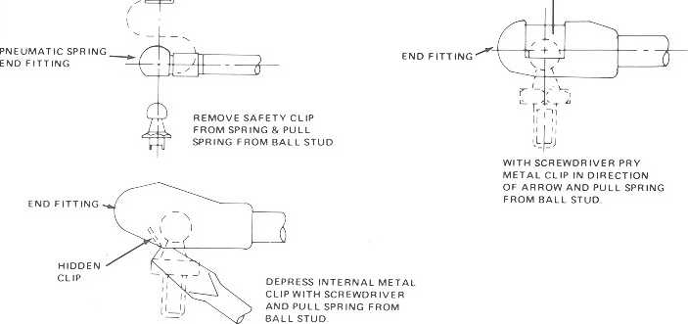
SAFETY CLIF
Figure 3-9. Dooi Spring Fittings
2. While another person keeps the door open, find the appropriate style spring end fitting in figure 3-9 and follow the example given.
Section 3: Routine Sen/tea
GLASS REPLACEMENT

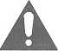

WARNING:
The top door gloss con brook or toll on you if you do not follow the reccommended removal procedure.

For your safety. Rowe does not recommend thai you replace [he lop door glass while the lop door Is on the phonograph. This procedure requires (wo people to remove [he lop door safely.

1.
Unplug the power to the phonograph.

2. Open the cabinet door

3. Unplug the 120 volt AC harness at the connector on the upper right side of the phonograph. Unplug the 3-pin connector from the central control computer and disengage the harness from the cable clamps.

4. Remove all of the top door hinge screws except for one screw and one nul at each end of the hinge.

5. With your helper still holding the top door open, disconnect the door springs (use the Door Spring procedure in this section If you are not familiar with the procedure for removing the door springs).

6. Remove the two remaining top door hinge screws while your helper continues to hold the top door open.

7. Again, using a helper, lift Ihe top door off of the phonograph and set the door on a clean smooth working surface (lay Ihe door so the outside is down).

8. Remove all of the shroud bracket screws from the four shroud brackets.

9. Lift out the brackets and the plastic shroud.

10. Be sure to protect your hands from broken glass with protective gloves before you remove the door glass. Remove The remaining glass with any available brush.

11. Set the new door glass in the door. re-Install the door shroud, and brackets.

21822ÙJI 3-¡7

CD-¡00 PhonogroDti

\2. Lift the door back ante, the phonograph and attach all screws and nuts through the hinge. Make sure that the door is centered before you tighten all of the screws.
- While your helper holds the door, reconnect the door springs and make sure that the door will be supported by the springs.
- Reconnect the 120 volt AC harness (on the right side of the phonograph) and the other harnesses on the left side of the phonograph and then push them into the cable clamps.
- Plug-in the phonograph and play a selection and make sure that the title rack pages tum_{T} all lights are on, and the animated discs turn.

16, Check the top door-to-OBA clearance and adjust the OBA if necessary (see GBA To Top Door Clearance fn Section 4 for Lhis procedure).

2)82261)

This Information is displayed as the number of units in Version 1,0 and 1.1 (money=uiiils x. multiplier and the display says: CASH =--------1. In Version 1.2 and subsequent, this value is displayed as the actual cash value (the display says: -CASH =--------).
This Information is displayed as the number of units in Version 1,0 and 1.1 (money=uiiils x. multiplier and the display says: CASH =--------1. In Version 1.2 and subsequent, this value is displayed as the actual cash value (the display says: -CASH =--------).

